**Question 1-**

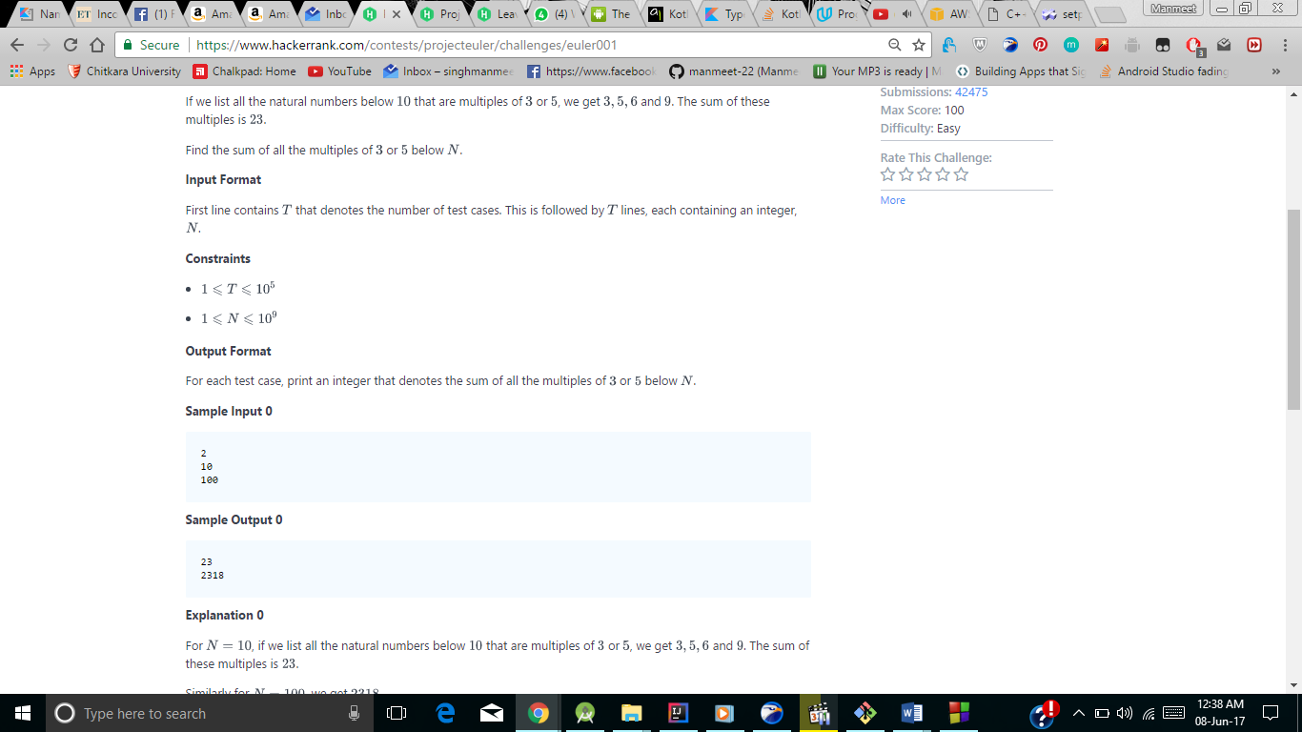

**Question 2-**

https://www.hackerrank.com/contests/projecteuler/challenges/euler002

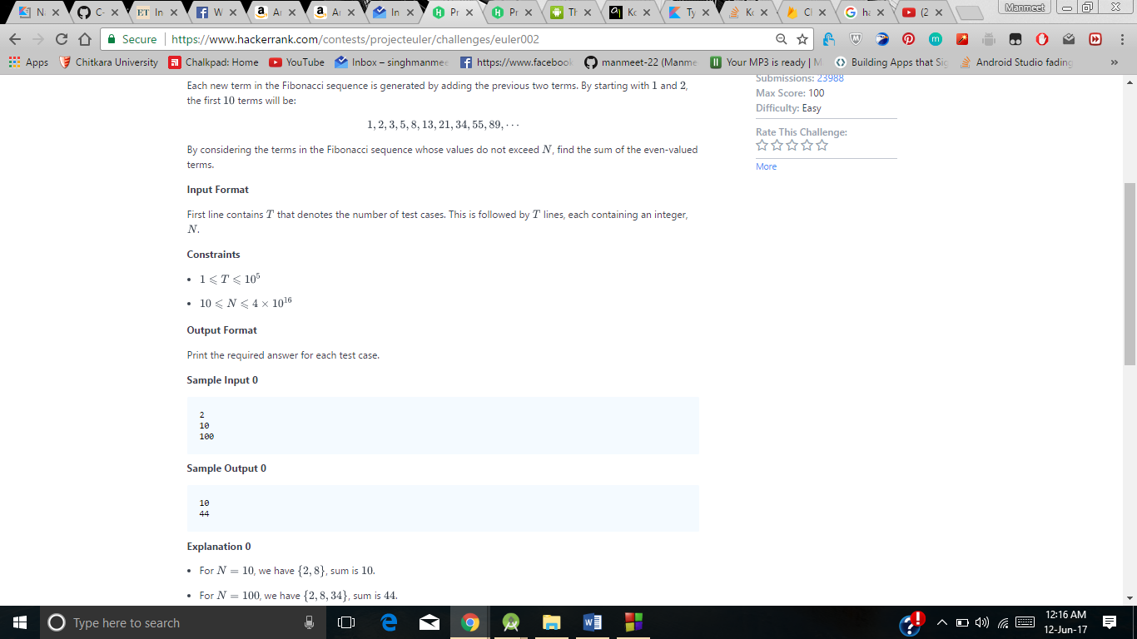

**Question 3-**

**Question 4-**